Schedule 1 – Payments to or for the States
Note: See Section 14

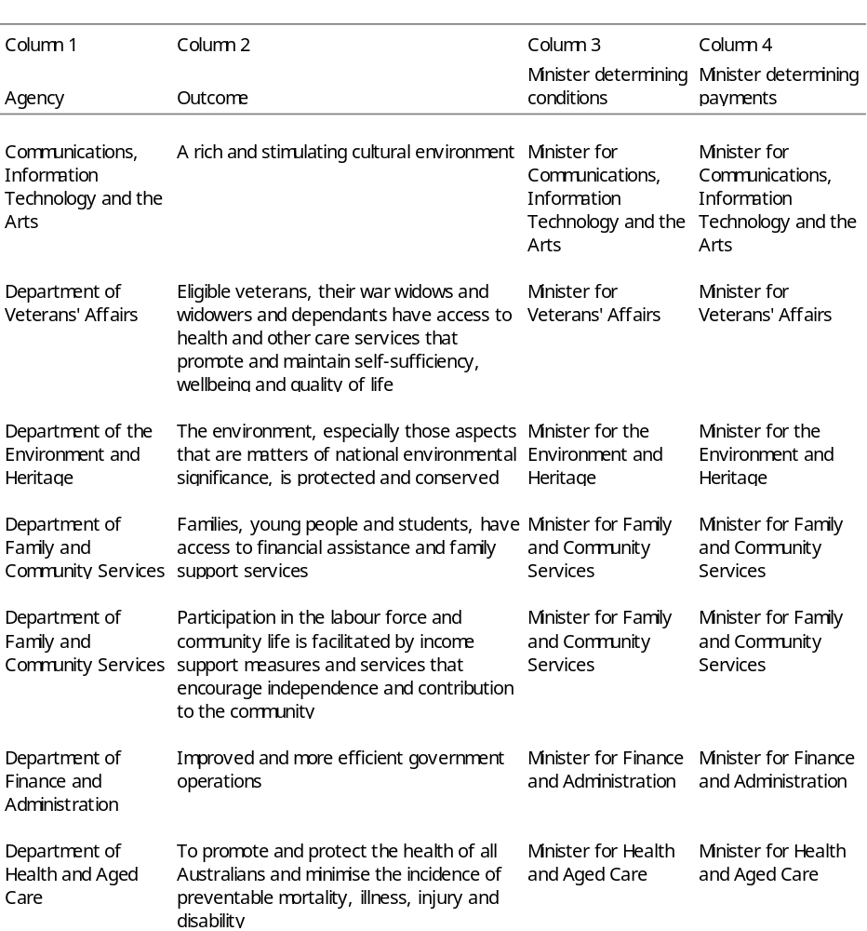
Continued

